**Lab 7: Managing Hadoop Storage**

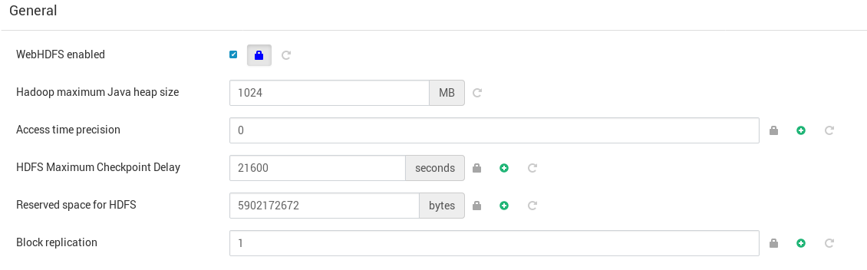

View the replication factor for the existing files in the root user’s HDFS home directory

The replication factor of an existing file can be changed. Use the HDFS Shell *-setrep* command to change the /user/root/hosts file’s replication factor from three to one. Verify the change once you are finished. Add another file to HDFS and its replication factor will be one as well.

